|  |  |
| --- | --- |
| Nikon D610  Máy ảnh Nikon D610  Nikon D610_06 Nikon D610_02 Nikon D610_05 Nikon D610_04 | **Featured information:**  EXPEED 3 image processor  24.3MP FX-format CMOS sensor  LCD screen 3.2  Record Full HD 1080p video at 30 frames per second  **Price : $ 900**  **Specifications:**  Sensor Format  APS-C (1.5x Crop Factor)  Resolution  21.51 Megapixels  Size photo  5568 x 3712  Image Proportions  3:2, 16:9  Sensor Type  CMOS  Image Format  JPEG, Raw  Anti-Vibration  Digital  Lens Mount  Nikon F |

**Overview:**

The Nikon D610 is a full-frame DSLR camera with a 24.3 MP CMOS FX sensor and EXPEED 3 processor that delivers high-resolution, full HD 1080p video with remarkable image detail. The Nikon D610 camera weighs only 757g, has compact dimensions of 142.2 x 111.8 x 81.3 mm, suitable for many subjects.

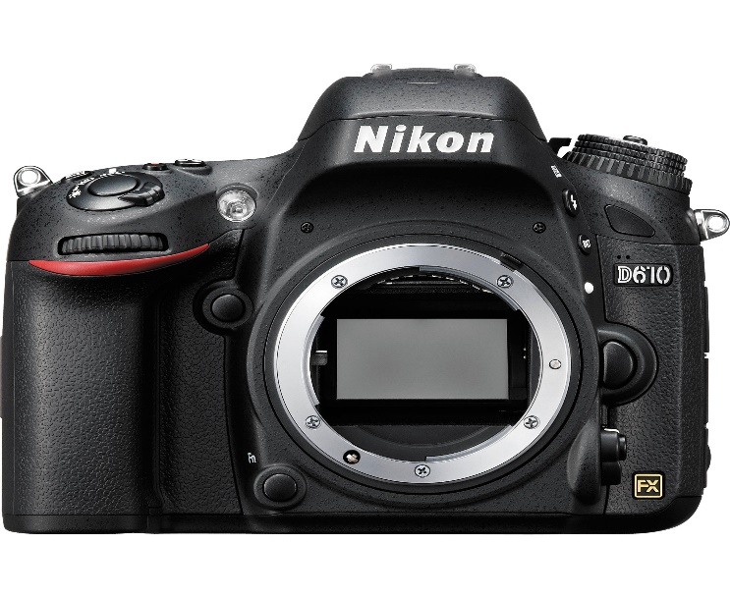

Even with a large FX-format sensor inside, the overall form of the Nikon D610 is still relatively compact and lightweight, enhancing portability. Built-in 3.2-inch 921K-dot LCD screen is available for playback of clear images as well as displaying menu navigation and live monitoring. Optical pentaprism viewfinder with 100% frame coverage and 0.7x magnification. Dual SD memory card slots support users to increase JPEG/RAW memory and partitioning capacity. The included flash gives you an additional light source, acting as a wireless controller capable of communicating i-TTL exposure information to two remote flash groups over three control channels.

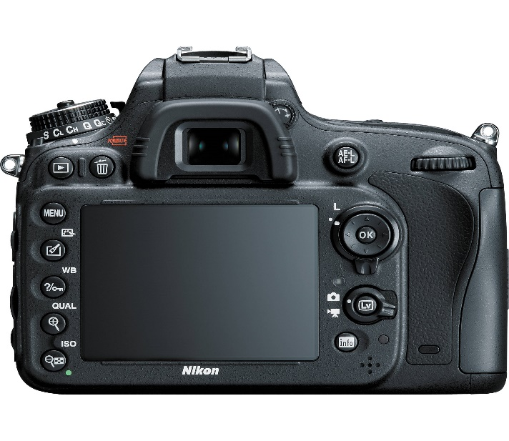

Equipped with a 24.3-megapixel full-frame CMOS sensor and EXPEED 3 image processor, the camera delivers overall high image quality with notable detail and relative accuracy. In addition, the Nikon D610 also possesses low light sensitivity with ISO 6400, supports full HD 1080p video recording, and continuous shooting speed with full resolution of 6 frames per second. This sensor can also record images in DX format and automatically switches to support the use of dedicated DX lenses when attached.

